Bible Timeline Review

The Bible Timeline Review is a “Got Time?” activity in the teacher's guide. Reviewing recent Bible stories using a timeline allows children to see the continuing story of who God is and what He has done. Instructions for creating the timeline are included at the beginning of each section.

This file contains the review cards for:
- God of Wonders Lessons 1-21 (Miracles of Jesus)
- God of Wonders Lessons 22-52 (Genesis through Joshua)
  - Includes Advent Lessons 48-52

Pages with a blank scroll and a blank footprint are included at the end of the document in case you want to add additional cards to the timeline.
God of Wonders Lessons 1-21

Bible Timeline Review

God of Wonders Part One studies the miracles of Jesus, which took place during His public ministry (Circa 30-33 A.D.). This list is not chronological, as the Bible does not give a definitive order of the miracles. Review recent Bible stories to see the continuing story of who God is and what He has done.

How to create a Bible Timeline for the Miracles of Jesus:
- Print each footprint on sturdy paper.
- Choose a wall or other visible location to display the timeline.
- Before each lesson, add the footprint for that lesson to the Bible Timeline using the list below. Children can follow in Jesus’ footsteps as they review past lessons.
- To review, ask the corresponding questions as you point to the associated footprint.

The Miracles of Jesus: (Circa 30-33 A.D.)
Changing Water into Wine > Filling the Nets > Calming the Storm > Healing Jairus’ Daughter > Feeding the Five Thousand > Healing the Centurion’s Servant > Healing the Paralyzed Man > Healing the Sick Woman > Healing the Deaf and Mute Man > Healing the Ten Men > Banishing an Evil Spirit > Saving the Official’s Son > Walking on Water > Giving Sight to the Man Born Blind > Raising Lazarus > Riding into Jerusalem > The Miracle of Easter > Appearing to the Disciples > Appearing to Thomas > Appearing on the Shore > Ascending into Heaven

* The numbers on the bottom right corner of each card are not the lesson numbers. They are the provided to give a suggested order for a timeline.

1
Changing Water
into Wine
2
Filling the Nets
3
Calming the Storm
4
Healing
Jairus’ Daughter
5
Feeding the
Five Thousand
6
Healing the
Centurion’s Servant
7
Healing the
Paralyzed Man
8
Healing the
Sick Woman
9
Healing the
Deaf and Mute Man
10
Healing the
Ten Men
11
Banishing an
Evil Spirit
12
Saving the
Official’s Son
13
Walking on Water
14
Giving Sight
to the
Man Born Blind
15
Raising Lazarus
16
Riding into
Jerusalem
17
The Miracle
of Easter
18
Appearing to the Disciples
19
Appearing
to Thomas
20
Appearing
on the Shore
21
Ascending
into Heaven
God of Wonders Lessons 22-52

Bible Timeline Review

God of Wonders Part Two studies the miracles and stories of the Bible from Genesis through Joshua. Review recent Bible stories to see the continuing story of who God is and what He has done.

How to create a Bible Timeline from Genesis through Joshua:
- Print each scroll on sturdy paper.
- Choose a wall or other visible location to display the timeline.
- Before each lesson, add the scroll for that lesson to the Bible Timeline using the list below. Add the two Unit 10 cards for God of Wonders Advent: Lessons 48-52.
- To review the Bible Timeline, ask the corresponding questions as you point to the associated scroll.

Genesis through Joshua: Creation > Adam and Eve > Cain and Abel > Noah (Circa 2350.B.C.) > Tower of Babel > Abram (Circa 2100 B.C.) > Hagar and Ishmael (Circa 2065 B.C.) > Abraham and Isaac (Circa 2050 B.C.) > Isaac and Rebekah > Jacob and Esau (Circa 1900 B.C.) > Joseph (Circa 1850 B.C.) > Moses (Circa 1500 B.C.) > Joshua (Circa 1450 B.C.)
Unit 10: John the Baptist (Circa 7-2 B.C.) > Jesus on Earth (Circa 2 B.C.-33 A.D.)

* The numbers on the bottom right corner of each card are not the lesson numbers. They are the provided to give a suggested order for a timeline.

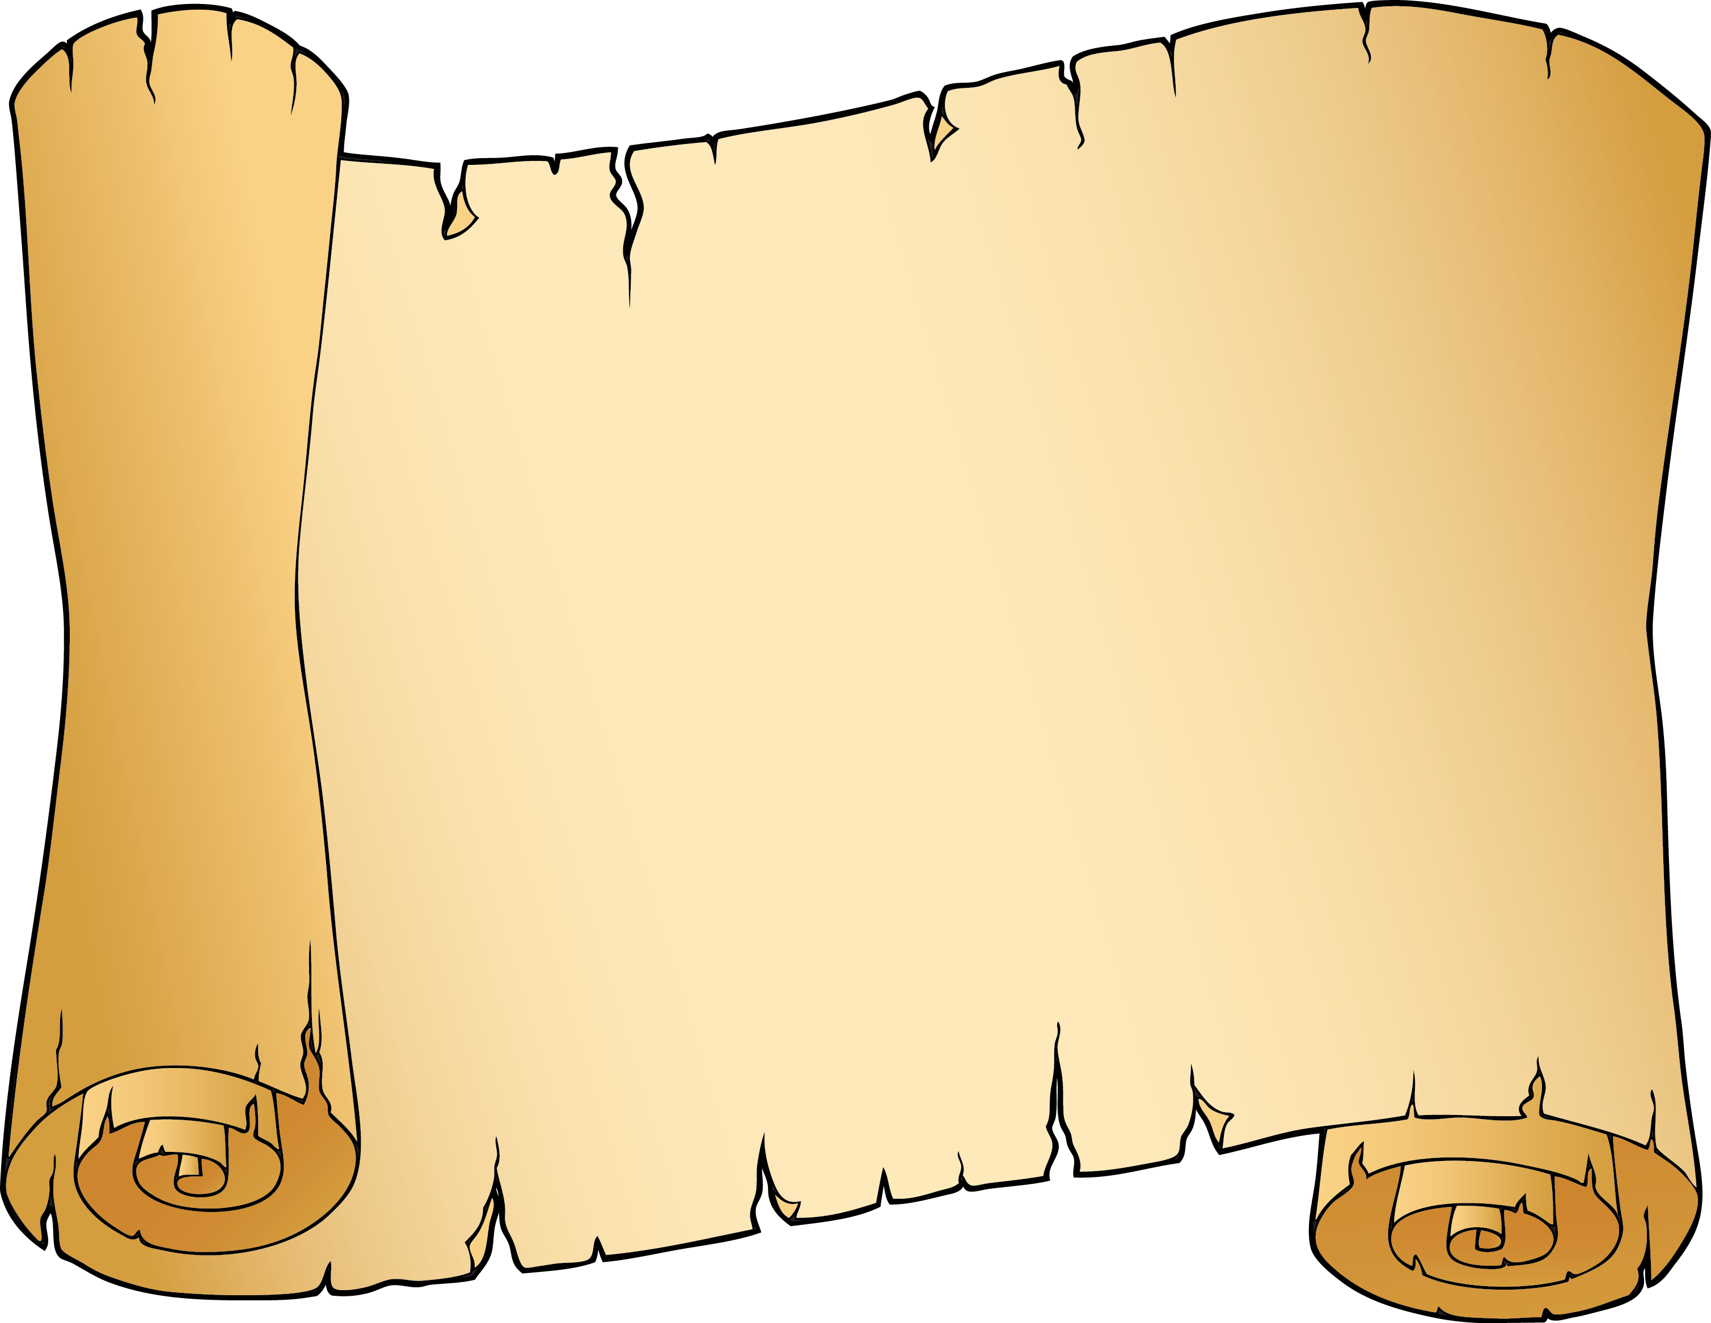
1
Creation
2
Adam and Eve
3
Cain and Abel
4
Noah
(Circa 2350 B.C.)
5
Tower
of Babel
6
Abram
(Circa 2100 B.C.)
7
Hagar
and Ishmael
(Circa 2065 B.C.)
8
Abraham
and Isaac
(Circa 2050 B.C.)
9
Isaac and Rebekah
10
Jacob
and Esau
(Circa 1900 B.C.)
11
Joseph
(Circa 1850 B.C.)
12
Moses
(Circa 1500 B.C.)
13
Joshua
(Circa 1450 B.C.)
14
John the Baptist
(Circa 7-2 B.C.)
15
Jesus on Earth (Circa 2 B.C.-33 A.D.)

