Bible Timeline Review

The Bible Timeline Review is a “Got Time?” activity in the teacher's guide. Reviewing recent Bible stories using a timeline allows children to see the continuing story of who God is and what He has done. Instructions for creating the timeline are included at the beginning of each section.

This file contains the review cards for:
- Kings & Kingdoms Lessons 1-22 (Life of Jesus)
- Kings & Kingdoms Lessons 23-32 (Kingdom Parables)
- Kings & Kingdoms Lessons 33-52 (Judges through Esther)
  - Includes Advent Lessons 48-52

Pages with a blank scroll and a blank footprint are included at the end of the document in case you want to add additional cards to the timeline.
Kings & Kingdoms Lessons 1-22

Bible Timeline Review

Kings & Kingdoms Part One studies the life of Jesus (Circa 0-33 A.D.) beginning with the only story of His childhood and then focusing on His relationships, His ministry, His teachings, and the events surrounding His death, resurrection, and ascension. It concludes with a study of His kingdom parables. Review recent Bible stories to see the continuing story of who God is and what He has done.

How to create a Bible Timeline for the Life of Jesus:
- Print each footprint on sturdy paper.
- Choose a wall or other visible location to display the timeline.
- Before each lesson, add the footprint for that lesson to the Bible Timeline using the list below. Children can follow in Jesus’ footsteps as they review past lessons.
- To review, ask the corresponding questions as you point to the associated footprint.

Life of Jesus: Jesus and His Father's House > Jesus Is Baptized > Jesus Is Tempted > Jesus Calls His Disciples > Jesus Clears the Temple > Jesus Is Transfigured > Jesus Teaches the Beatitudes > Jesus and Nicodemus > Jesus and the Woman at the Well > Jesus with Mary and Martha > Jesus and Zacchaeus > Jesus Is Anointed > The Triumphal Entry > Jesus Washes His Disciples' Feet > Jesus and the Last Supper > Jesus in the Garden > Jesus and the Cross > Jesus Is Risen > The Road to Emmaus > Jesus Talks with Peter > The Great Commission > The King Ascends

*These footprints are in found in the Kingdom Parables Review for Lessons 23-32.
Kingdom Parables: The Lost Sheep > The Sower > The Vine and The Branches > The Workers in the Vineyard > The Great Banquet > The Rich Fool > The Talents > Lazarus and the Rich Man> The Lost Son > The Good Samaritan

1
Jesus and His Father's House
2
Jesus Is Baptized
3
Jesus Is Tempted
4
Jesus Calls
His Disciples
5
Jesus Clears
the Temple
6
Jesus Is Transfigured
7
Jesus Teaches
the Beatitudes
8
Jesus and Nicodemus
9
Jesus and the Woman at the Well
10
Jesus with Mary
and Martha
11
Jesus and Zacchaeus
12
Jesus Is Anointed
13
The Triumphal Entry
14
Jesus Washes
His Disciples' Feet
15
Jesus and
the Last Supper
16
Jesus in the Garden
17
Jesus and the Cross
18
Jesus Is Risen
19
The Road to Emmaus
20
Jesus Talks with Peter
21
The Great Commission
22
The King Ascends
Kings & Kingdoms Lessons 23-32

Kingdom Parables Review

Kings & Kingdoms Part One studies the life of Jesus. Lessons 23-32 explore the parables Jesus told to teach us about His kingdom. The previous lesson will always be reviewed briefly in The Word segment of each Teacher’s Guide. Review recent Bible stories to see the continuing story of who God is and He has done.

How to create a display for reviewing the Kingdom Parables:
- Print each footprint on sturdy paper.
- Choose a wall or other visible location to display the footprints.
- Before each lesson, add the footprint for that lesson to the display using the list below. Children can follow in Jesus’ footsteps as they review past lessons.
- To review, ask the corresponding questions as you point to the associated footprint.

Kingdom Parables: The Lost Sheep > The Sower > The Vine and the Branches > The Workers in the Vineyard > The Great Banquet > The Rich Fool > The Talents > Lazarus and the Rich Man > The Lost Son > The Good Samaritan

* The numbers on the bottom right corner of each card are not the lesson numbers. They are the provided to give a suggested order for a timeline.
1
The Lost Sheep
2
The Sower
3
The Vine and
the Branches
4
The Workers
in the Vineyard
5
The Great Banquet
6
The Rich Fool
7
The Talents
8
Lazarus and
the Rich Man
9
The Lost Son
10
The Good Samaritan
Kings & Kingdoms Lessons 33-52

Bible Timeline Review

Kings & Kingdoms Part Two studies the miracles and stories of the Bible from Judges through Esther. Review recent Bible stories to see the continuing story of who God is and what He has done.

How to create a Bible Timeline from Judges through Esther:
- Print each scroll on sturdy paper.
- Choose a wall or other visible location to display the timeline.
- Before each lesson, add the scroll for that lesson to the Bible Timeline using the list below. Add the Unit 10 card for Kings & Kingdoms Lessons 48-52.
- To review, ask the corresponding questions as you point to the associated scroll.

Judges – Esther: Deborah (Circa 1350 B.C.) > Gideon (Circa 1250 B.C.) > Samson (Circa 1150 B.C.) > Ruth > Samuel (Circa 1100 B.C.) > Saul (Circa 1050 B.C.) > David (Circa 1020 B.C.) > Solomon (Circa 970 B.C.) > Josiah (Circa 640 B.C.) > Ezra (Circa 500 B.C.) > Esther (Circa 470 B.C.) > Nehemiah (Circa 430 B.C.)
Unit 10: Jesus on Earth (Circa 2 B.C.-33 A.D.)

Teacher Tip: To view Bible Timeline and lessons from Genesis through Joshua, see Year One, God of Wonders Lessons 22-47.

* The numbers on the bottom right corner of each card are not the lesson numbers. They are the provided to give a suggested order for a timeline.

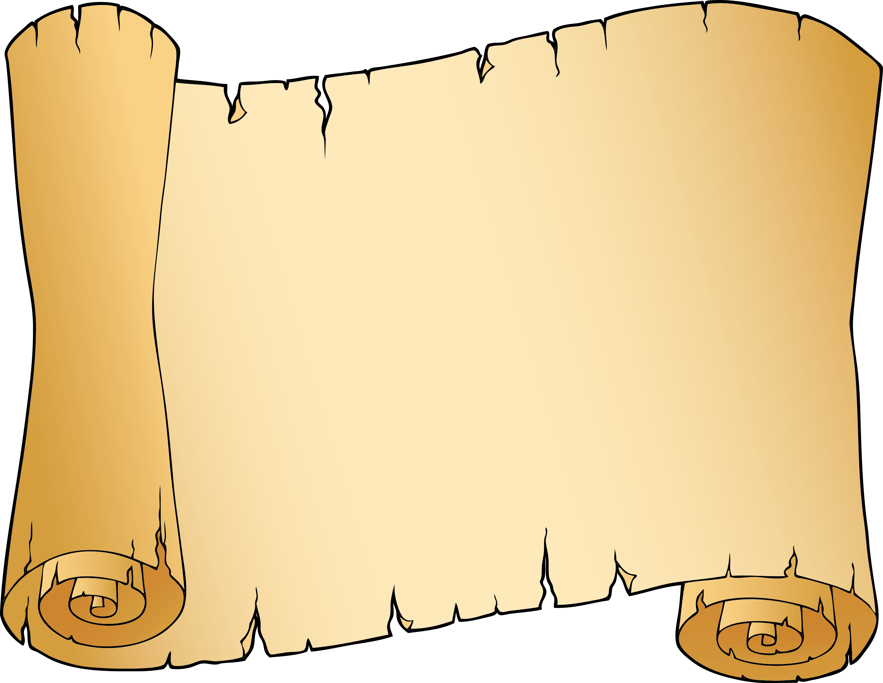
1
Deborah
(Circa 1350 B.C.)
2
Gideon
(Circa 1250 B.C.)
3
Samson
(Circa 1150 B.C.)
4
Ruth
5
Samuel
(Circa 1100 B.C.)
6
Saul
(Circa 1050 B.C.)
7
David
(Circa 1020 B.C.)
8
Solomon
(Circa 970 B.C.)
9
Josiah
(Circa 640 B.C.)
10
Ezra
(Circa 500 B.C.)
11
Esther
(Circa 470 B.C.)
12
Nehemiah (Circa 430 B.C.)
13
Jesus on Earth (Circa 2 B.C.-33 A.D.)

